**AIM**:-Write a program for searching a number using BINARY SEARCH

**SOURCE CODE**

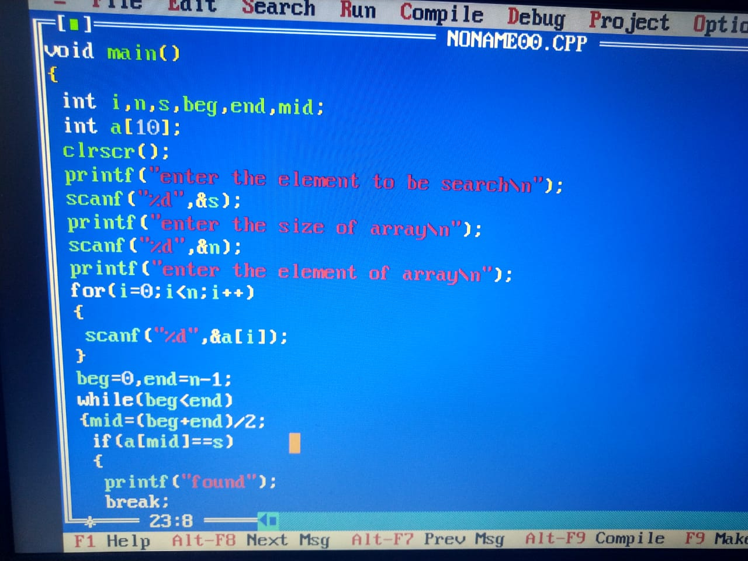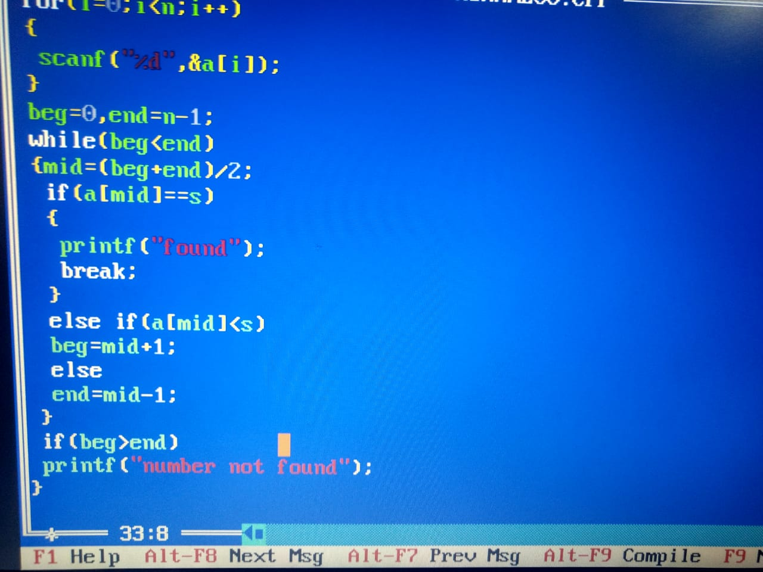

**OUTPUT**

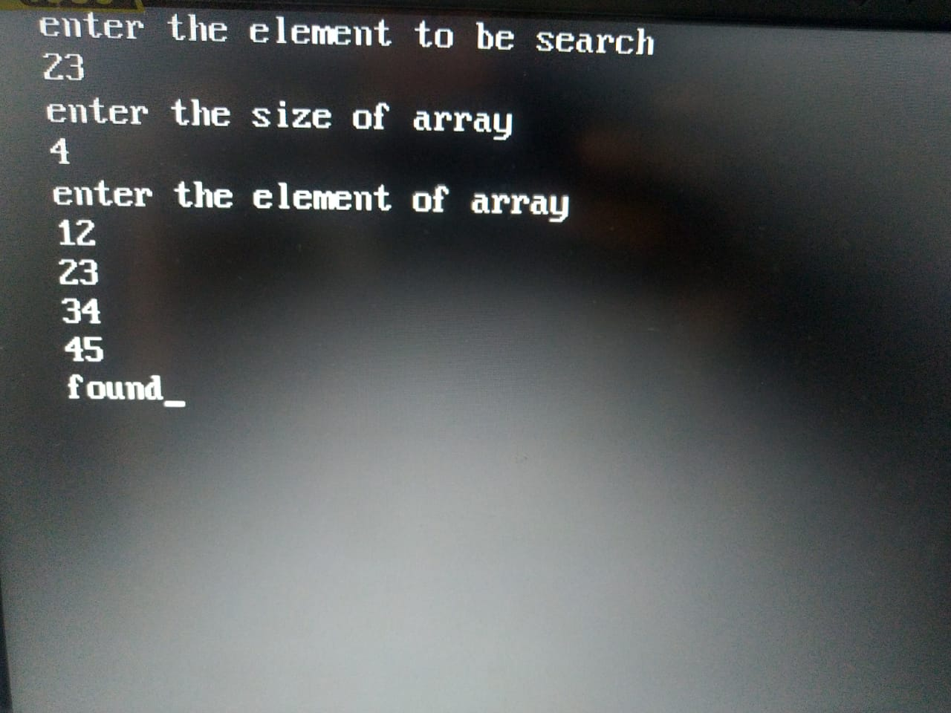

**AIM**:-Write a program for searching a number using LINEAR SEARCH

**SOURCE CODE**

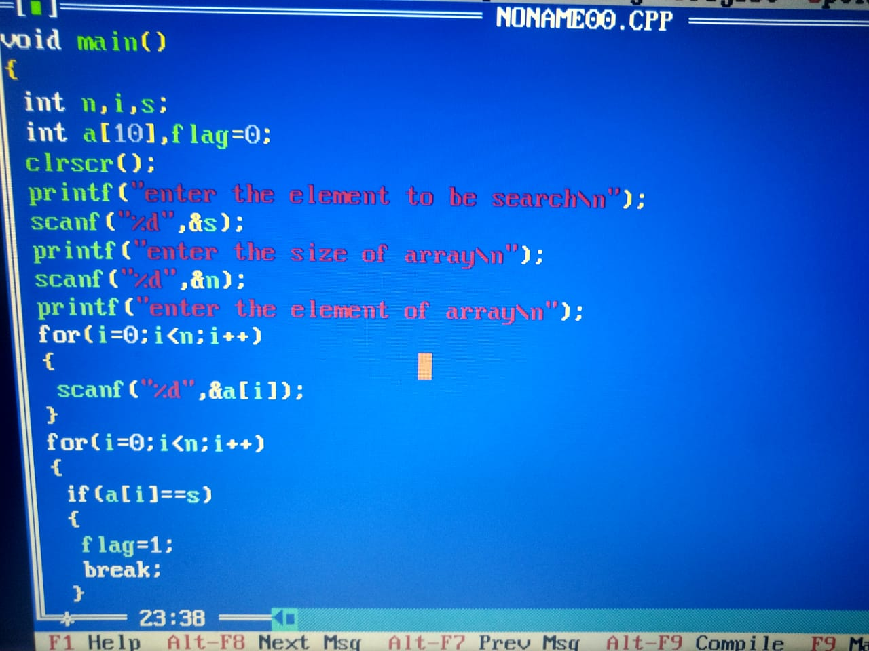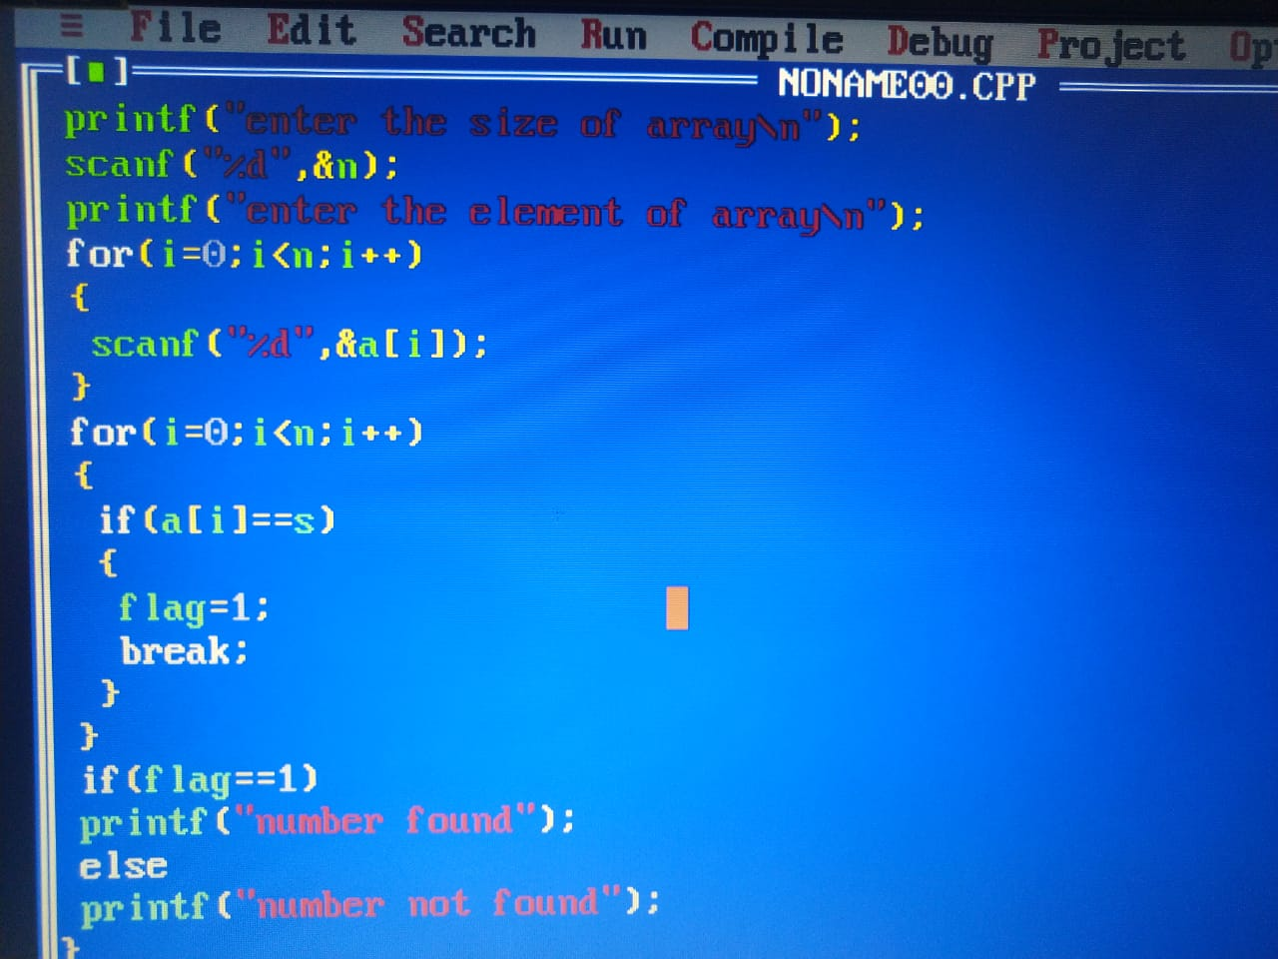

**OUTPUT**

